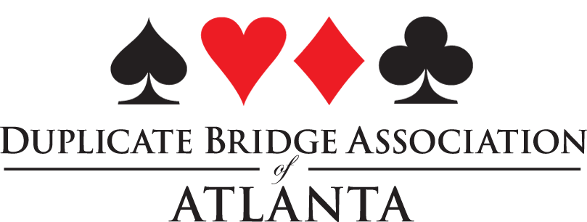Draft

DBAA/ Unit 253 Board Meeting
March 12, 2022, 9:30 am via Zoom

Officers: Marty Nathan, Linda Hagood, Denise DeAngelo,
Unit Reps: Becky Butler, Jack Feagin, John Simms, Melissa Taylor, Sue Williams

Marty Nathan called the meeting to order.
Old Business
Marty Nathan made a motion to approve the minutes of the January 8, 2021, board meeting. Approved.
Committee Reports
The DBAA Game Club Manager is Marty Nathan. The game is currently not being held due to COVID-19.
DBAA needs a chairperson for the following committees:
Awards, Directory, Education and Membership.
New Business
Atlanta bridge clubs may host one Change of Rank party in which players who have changed ranks in 2020 or 2021 get a free play. The DBAA would like to have one board member attend each party in order to recognize the achievements these players have made. Jack Feagin made a motion to change the amount of money the DBAA reimburses clubs for the Change of Rank party from $75.00 to $100.00. The DBAA will also provide additional funding of $5.00 per table for games over 20 tables up to a maximum of $100.00. Approved.
Melissa Taylor has agreed to chair the Mentor Program this year. The program is usually held in May, but because of COVID-19 related low attendance at clubs, the board agreed to hold this program later in the year.
The ACBL sends several monthly and quarterly reports to the secretary of the DBAA. For the next round of reports, Marty Nathan suggested that Denise DeAngelo email the reports to all board members. If board members would like to continue receiving the reports, they must let Denise know.
Sue Williams made a motion to recommend Jack Feagin as chairperson of the NABC tournament to be held in November 2023. Jack asked that District 7 approve his nomination before he names a co-chair. Approved.
The meeting was adjourned.

Respectfully submitted,

Denise DeAngelo, Secretary DBAA

